How To Be A Viking Camp
Norwegian Culture Children’s Program

WEEK 1: HOW TO BE A VIKING
Opening Large Group Story: The Race of the Birkebeiners, by Lisa Lunge-Larsen
Crafts
- Wood Cookie Rune Name Tags
- Foam Viking ships
- Painting rune stones
- Decorating Viking shields and tunics
- Rice Crispy Viking ships
Music and Dance
- Norwegian Folk Dance (Allemand march and mixer)
- Chistmas Songs (Vi Klappe handene
Games/Activities
- Viking Kubb
- Kjeppepine (Stick Game)
Food:
- Lefse w/ butter og sugar
- Brunøst and crisp bread
- Salami
- Raw root vegetables
- Lingonberry Saft
- Rice Crispy treat Viking ships with Marshmallow sails
Based on number of Campers: 24
Based on number of Adults: 8

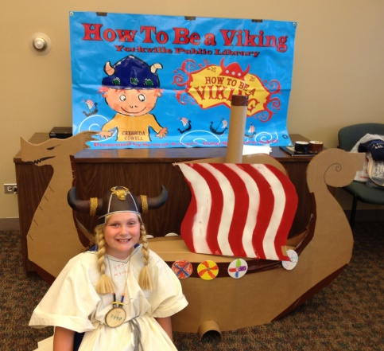

Week 1 photos
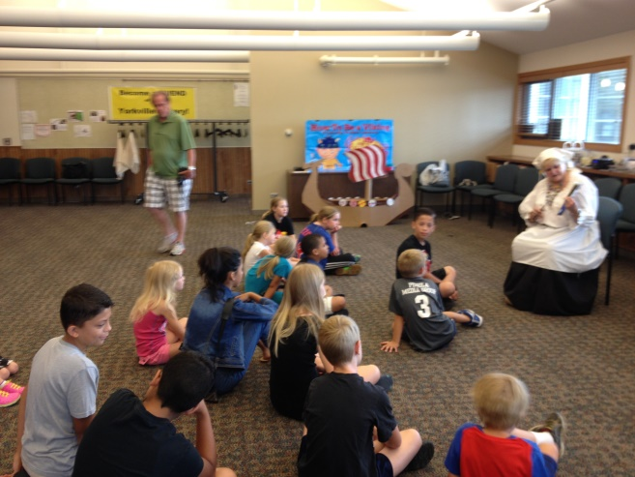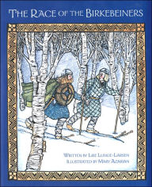
Viking story time
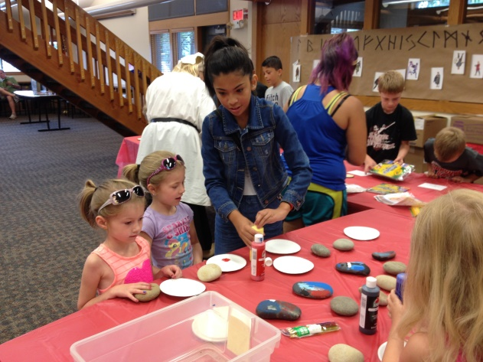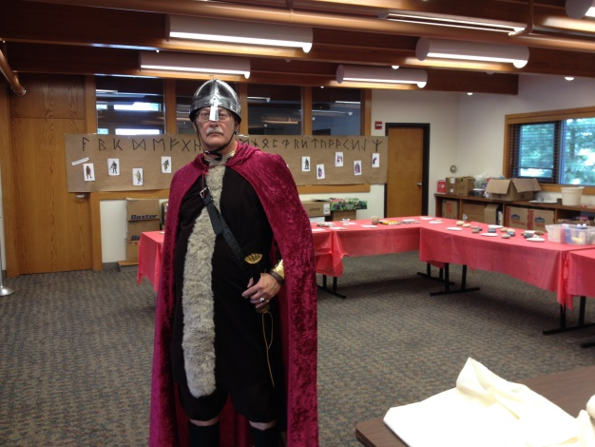
Viking campers painting rune stones Viking helpers
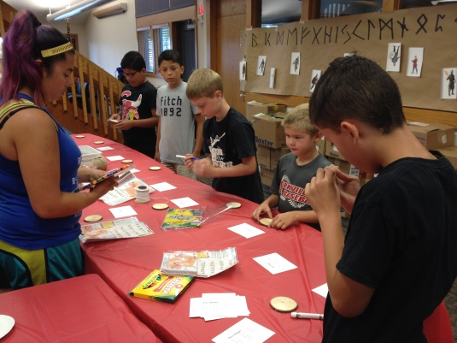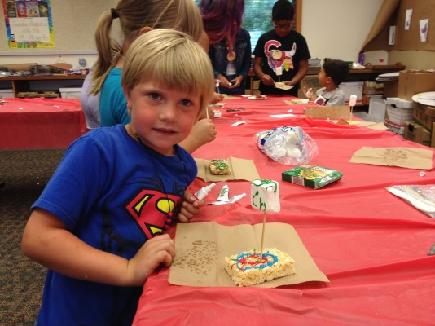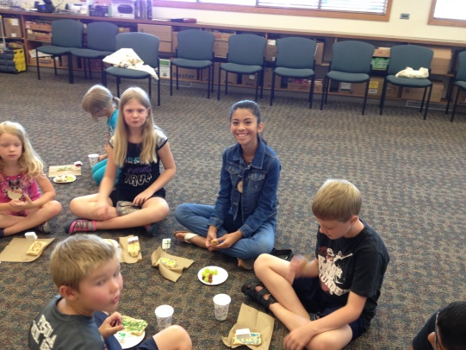
Making wood cookie rune name tags making rice crispy treat Viking ships Campers enjoying the food

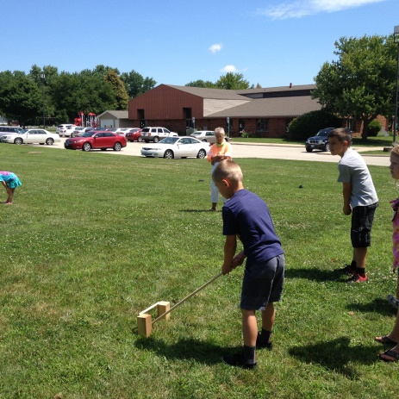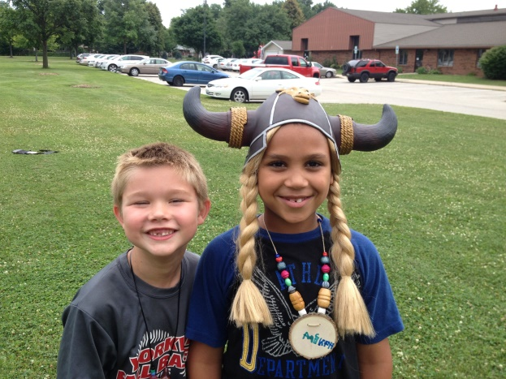
Kjeppepinne Making new Viking friends!

WEEK 2: HULDRA, NISSE and TROLLS…Oh My!

Opening Large Group Story: (Pick a story about Trolls)
Craft
- Clay Trolls
- Rosemalling with colored pencils
- Creating Hnefatafl Boards
Music and Dance
- Norwegian Folk Dance - Alamon
- Norwegian Chirstmas Songs -
Games/Activity
- Library “Troll Hunt”
- Troll Foot races
- Kjeppepinne and Kubb
- Hnefatafl – the Viking Board Game
Food:
- Making Smørbrod (ham, salami,egg, lettuce, pickles, tomatoes)
- Lingonberry bars
- Black currant saft

Number of Campers: 20

Number of adults: 6

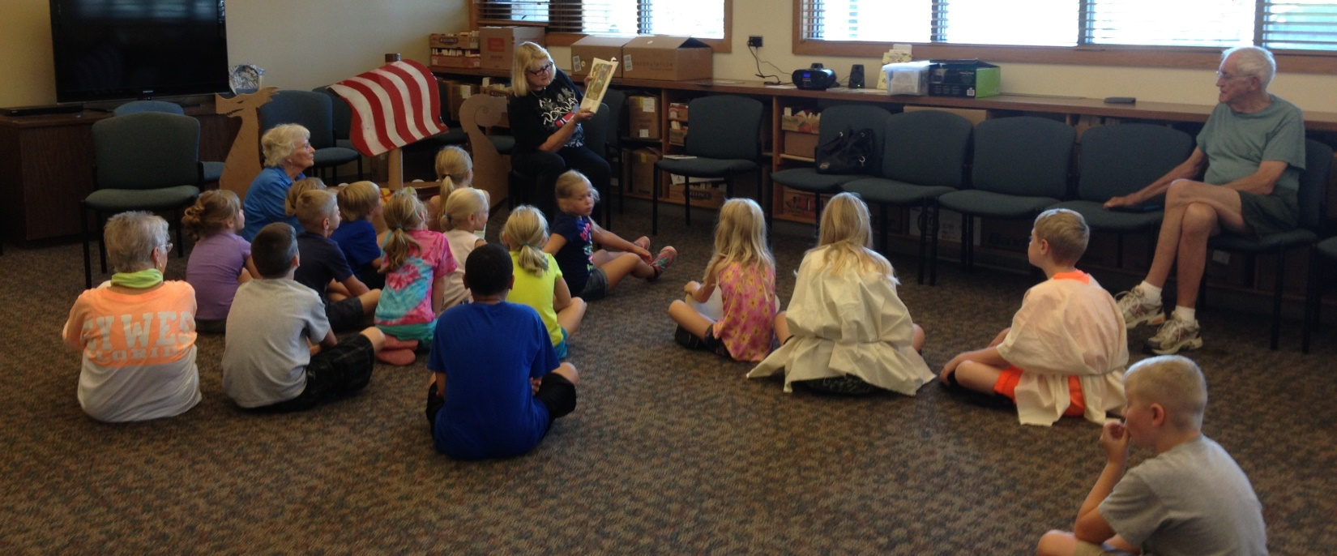
Learning about Trolls
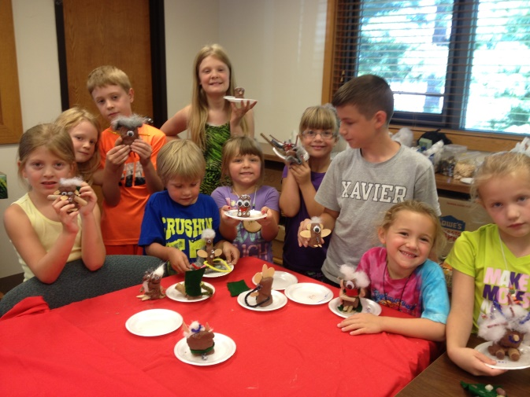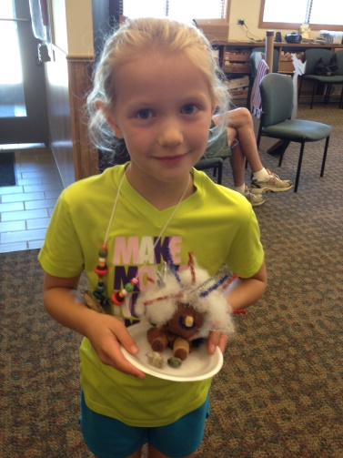
Making trolls
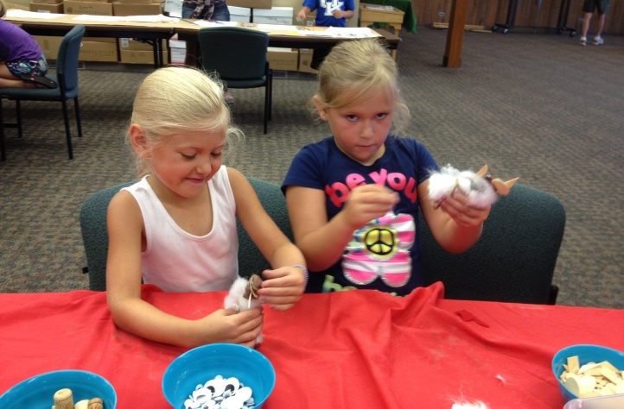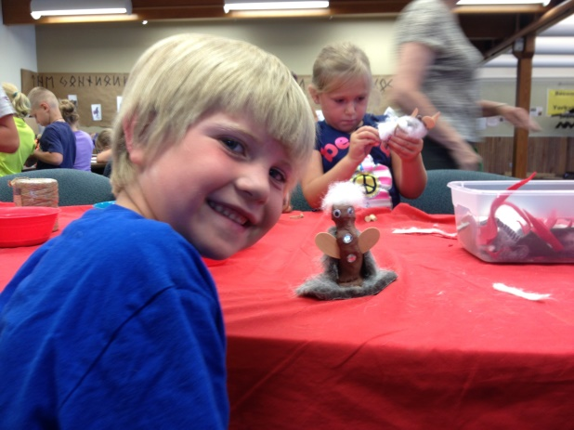
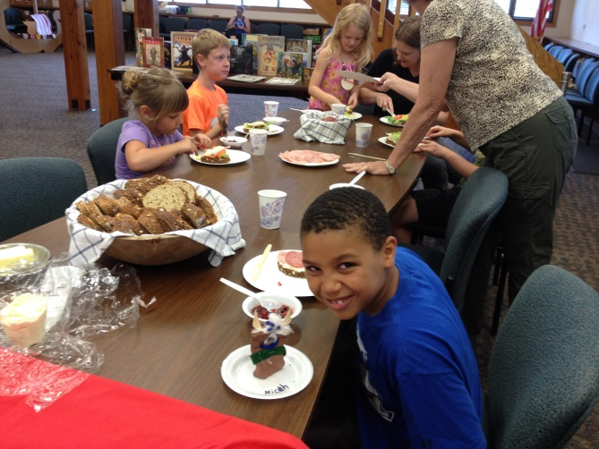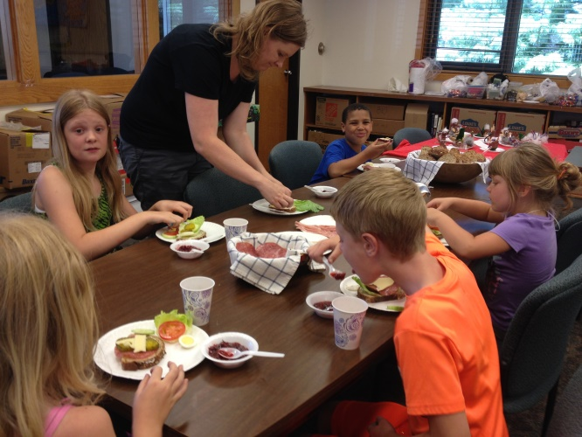
Creating and eating smørbrod
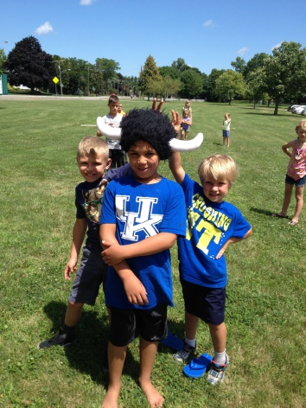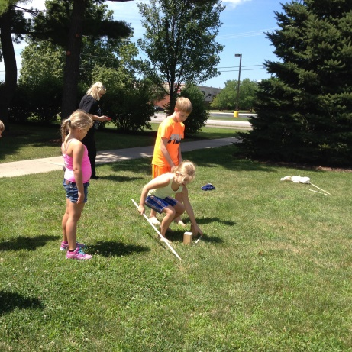
Day two of Kjepepinne

WEEK 3: NORWEGIAN CELEBRATIONS - JULETREFEST
Opening Large Group: A Christmas Wish
Music:
Klappe handene
Fødselsdagen - The Norwegian Birthday Song
Crafts
- Decorating Christmas Cookies
- Heart Baskets

Activities:
- Christmas Treasure Hunt
- Decorating the Juletre
- Christmas Program for Library staff and Parents

Food
- Ris krem
- Fruit Soup
- Julesmåkaker (kransekake, lingonberry bars, kringla, Norwegian Lace, almond tarts and pepperkake)
- Elderberry Saft

Number of Participants: 26
Number of Adults: 8

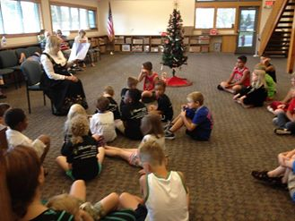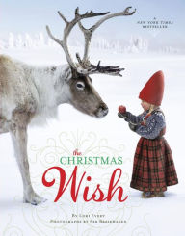

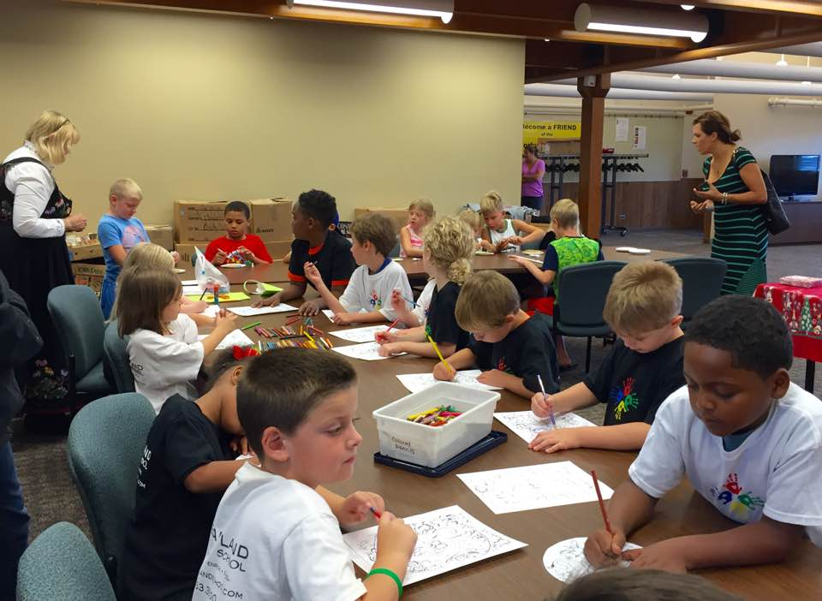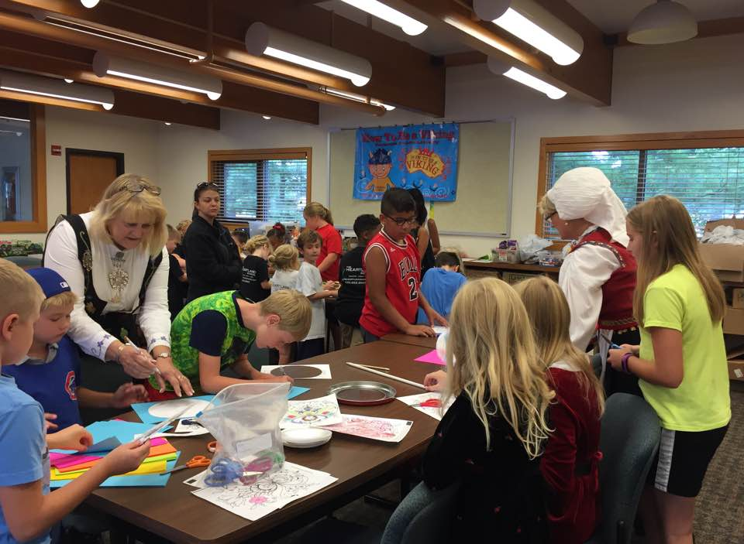
Making heart baskets for the juletre
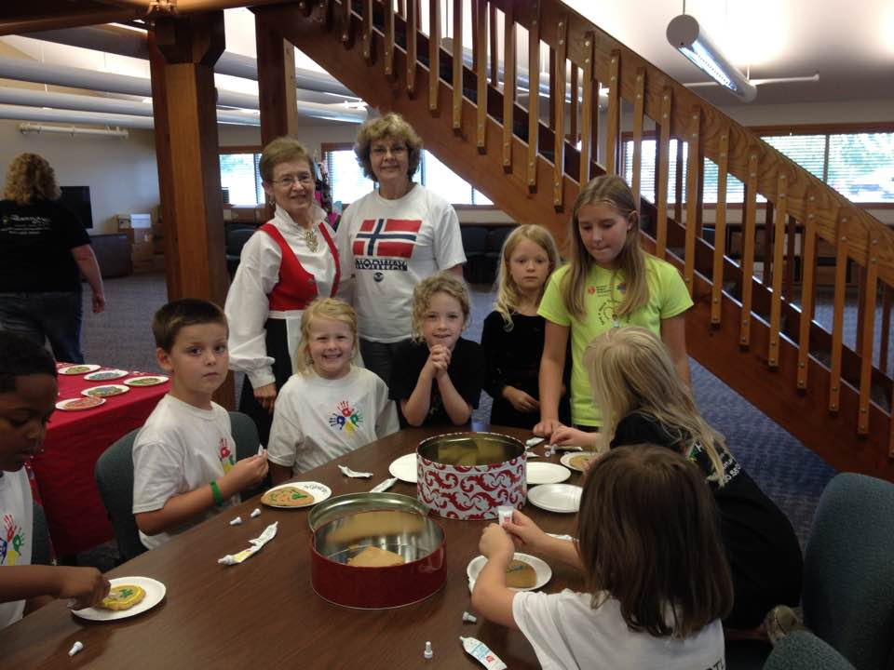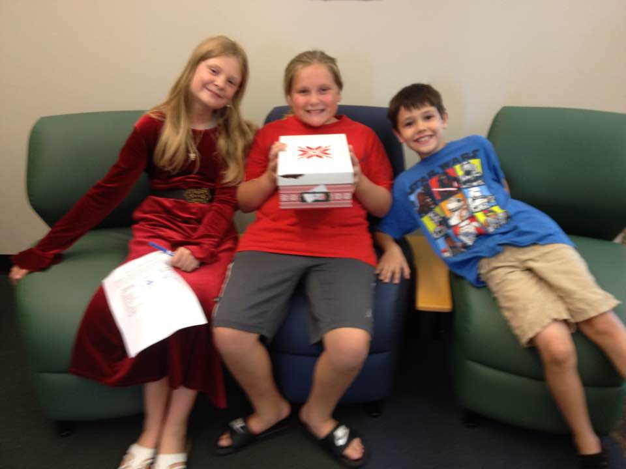
Decorating cookies Christmas Treasure hunt
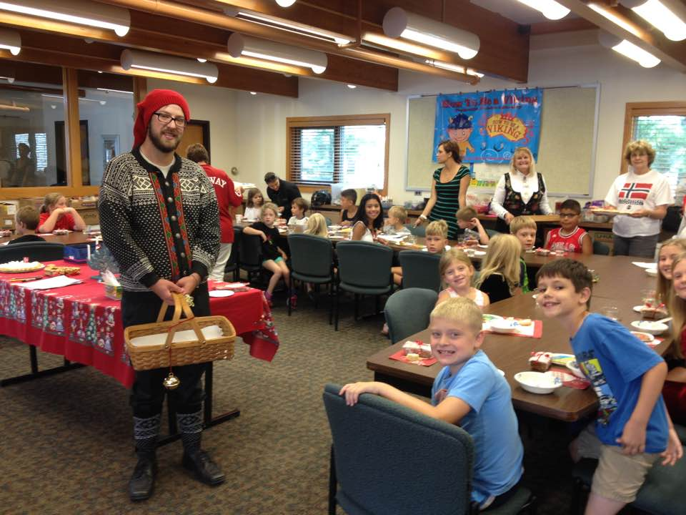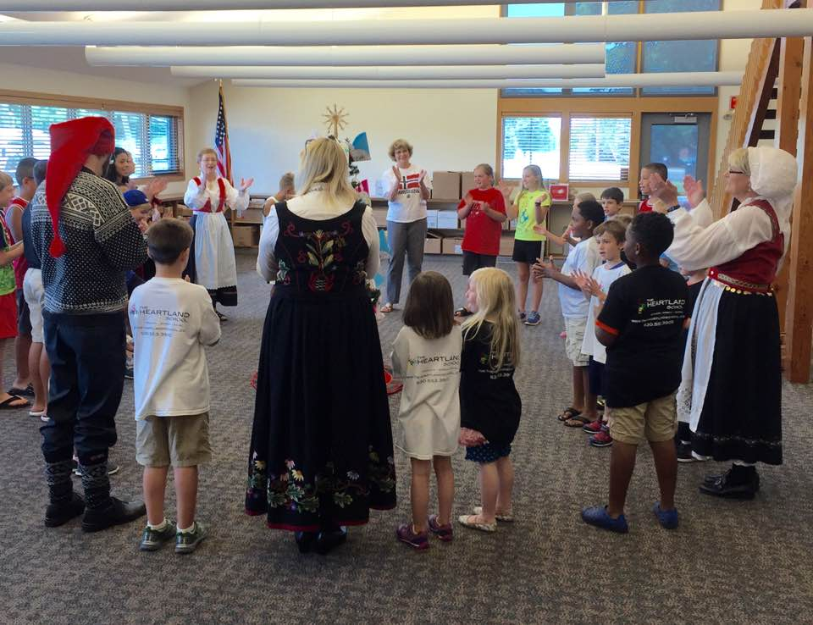
A visit form the julenisse Singing around the juletre
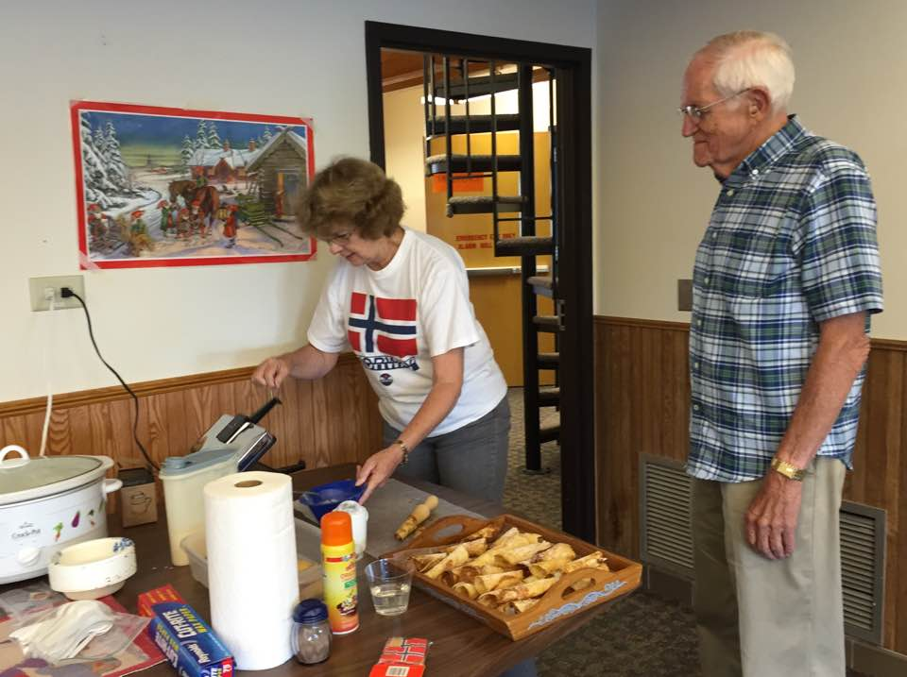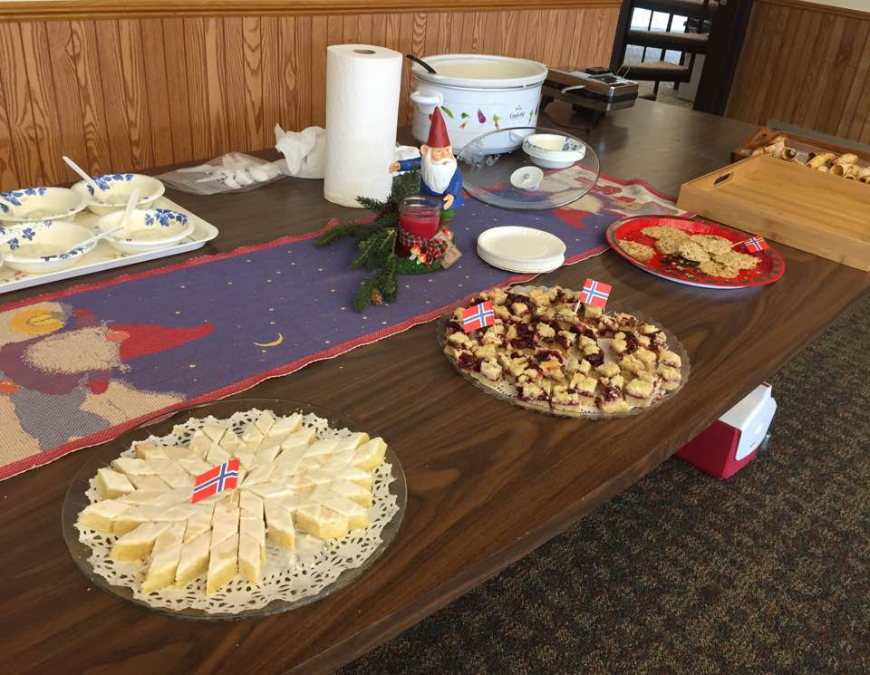
Serving Rice Cream, fresh krumkake and seven types of Christmas cookies

How To Be A Viking Expenses 2016

Supplies:
Craft Groups
Hancock fabrics
- fabric for tunics, helmets & Hnefatafl boards $121.57
Hobby Lobby
- markers, paint, craft supplies, clay $13.10
Ground Effects (rune stones) $12.99
Jewel (Food for snacks) $20.73
Walmart
(Food, paper products and craft supplies) $76.54

Room Rental ($60.00 per day) $50.00 library donation
Waived by the library

Donated Food:
- 4 - jars of lingonberry jelly @3.99 =
- 2 - 16 oz. of Gietøst cheese @ $14.59 =
- 3 – 8 oz. of almond paste @ $4.99
- Lefse ingredients
- Lingonberry Bar ingredients
- Pepperkake ingredients
- Kransekake ingredients
- Krumkake ingredients
- Rice crispy treat ingredients
- 6 bottles of saft @$5.00 per bottle
- Crisp bread

TOTAL: $303.13

